A

PROJECT REPORT

ON

**Car Rental System**

Towards partial fulfillment of the requirement in

**2nd Semester BCA/B.Sc. IT/IMCA 2021-22**

**Submitted By:-**

210510123009 Harshil patel

210510126002 Sankalp Kumar

210510123012 Shaikh Yamanuddin

210510124035 Jay Parag Joshi

**Submitted To:-**



**Parul Institute of Computer Application,**

**Parul University.**

Under the Guidance of

Prof./Dr. Manish kumar Joshi

**Acknowledgement**

*The success and final outcome of this project required a lot of guidance and assistance from many people and we are extremely privileged to have got this all along the completion of our project. All that we have done is only due to such supervision and assistance and we would not forget to thank them.*

*I respect and thank Dr. Priya Swaminarayan, Dean, FITCS for providing us an opportunity to do the project work in BCA and giving us all support and guidance which made us complete the project duly. We are extremely thankful to Mam for providing her support and guidance, although she had a busy schedule managing the academic affairs.*

*We would not forget to remember Prof. Hina Chokshi, HOD, BCA department for her encouragement and more over for her timely support and guidance till the completion of our project work.*

*We owe our deep gratitude to our project guide Dr./Prof. Manish Kumar Joshi , who took keen interest on our project work and guided us all along, till the completion of our project work by providing all the necessary information for developing a good system.*

*I am thankful to and fortunate enough to get constant encouragement, support and guidance from our Parents, all Teaching staff of the BCA Department which helped us in successfully completing our project work. Also, we would like to extend our sincere esteems to all staff in the laboratory for their timely support.*

***[Harshil Nilesh Patel] [210510123009]***

***[Sankalp Kumar] [210510126002]***

***[Shaikh Yamanuddin ] [210510123012]***

***[Jay Parag Joshi] [210510124035]***



**PARUL INSTITUTE OF COMPUTER APPLICATION**

**CERTIFICATE**

This is to certify that ***Harshil Nilesh Patel, Sankalp Kumar, Shaikh Yamanuddin and Jay Parag Joshi*** the student(s) of Parul Institute of Computer Application, has/have satisfactorily completed the project entitled ***“__Car Rental System”*** as a part of course curriculum in BCA/B.Sc. IT/IMCA semester-II for the academic year 2021-2022 under guidance of ***Dr. /Prof. Manish Kumar Joshi.***

Enrollment Number: 210510123009

Enrollment Number: 210510126002

Enrollment Number: 210510123012

Enrollment Number: 210510124035

|  |  |  |
| --- | --- | --- |
| **Quality of work** | **Grade** | **Sign of Internal guide** |
| **Poor / Average / Good /**  **Excellent** | **B /B+ / A / A+** |  |

Date of submission:

HOD, Principal,

Prof. Hina Chokshi Dr.Priya Swaminarayan

**INDEX**

|  |
| --- |
| **Content** **Page No.** |
| 1. Introduction to Project System |
| 1. System Requirement Specification |
| * 1. Introduction to SRS |
| * 1. Hardware Requirement |
| * 1. Software Requirement |
| * 1. System Users |
| * 1. Description of User Role |
| * 1. System Modules |
| * 1. Description of Modules |
| * 1. Timeline Chart |
| 1. System Flow Diagram |
| 1. Data Flow Diagram (All Levels of DFDs) |
| 1. Use Case Diagram |
| 1. Data Dictionary |
| 1. Screenshots of Development Phase -1 |
| 1. Screenshots of Development Phase -2 |
| 1. Screenshots of Development Phase -3 |
| 1. Conclusion |
| 1. Future Enhancement |
| 1. References |

**ABSTRACT**

Customer will be able to reserve their car from anywhere in the world using Car Rental System. Customer will offer record to the system through filling of their private records. When customer creates an account on the website, he or she will we able to reserve a car. The system will effectively and efficiently automates manual procedures. It contain the information about the car they want to hire. It help the user to search for available cars view profile and book the cars for the time period. It has a user-friendly interface which make it easy for user to use the website. This Car Rental System make the booking easy. The aim of this system is to create a website where customer can book their car from anywhere in the world.

**Chapter 1**

**Introduction to Project System**

CAR RENTAL SYSTEM is a web-based system for a company or an individual that rent out cars. This system enables the company or an individual to make their service available to the public through the internet and also keep records about their services.

Transport facility is a problem for those people who do not have any personal transport. On the occasion like wedding, vacation, house shifting and many more they feel the necessity of vehicle to sort out the problems. Car rental system is beneficial for both customer and transport provider. The car rental system is the online facility to book cars online with few clicks only. Some people cannot afford to have car, for those people this system is very helpful. This system includes cars, as per the customer requirements and comfort.

**Chapter 2**

**System Requirement Specification**

**2.1 Introduction to SRS**

**2.1.1 What is SRS?**

A software requirements specification (SRS) is a description of a software system to be developed. It lays out functional and non-functional requirements, and may include a set of use cases that describe user interactions that the software must provide.

**2.1.2 Need of SRS**

In order to fully understand one’s project, it is very important that they come up with a SRS listing out their requirements, how are they going to meet it and how will they complete the project. It helps the team to save upon their time as they are able to comprehend how are going to go about the project. Doing this also enables the team to find out about the limitations and risks early on.

**2.2 Hardware Requirement**

|  |  |
| --- | --- |
| **Hardware Components** | **Specification** |
| Processor | Intel core I3,/I5 |
| RAM | 4GB/8GB |
| Hard disk | 512GB/1TB |
| Monitor | 15.6 color monitor or advance |
| Device | Keyboard, Mouse |

**2.3 Software Requirement**

|  |  |
| --- | --- |
| **Name of component** | **Specification** |
| Operating System | WindowsXP, windows10 |
| Control Panel | Xampp Control Panel/Wamp Control Panel |
| Software development kit | Google Chrome, Internet Explorer, Mozilla Firefox (any appropriate or suitable browser) |
| Programming Language | PHP, HTML, JAVASCRIPT |
| Server | Apache Web Server |
| Database | MySQL |

**2.4 System Users**

2.4.1 User

2.4.2 Admin

**2.5 Description of User Role**

**2.5.1 User**

User are the person which are register on the website and can view the car details and make booking. Anyone can

* + 1. **Admin**

The admin entity that will monitor activities, manage booking, User, Pages,

**2.6 System Features**

2.6.1 Registration

2.6.2 User login

2.6.3 Admin login

2.6.4 Booking

2.6.5 Manage Company

2.6.6 Manage brands

2.6.7 Manage vehicles

2.6.8 Manage bookings

**2.7 Description of Features**

**2.7.1 Registration**

Any person can register on the website by filling the registration form

**2.7.2 User login**

It allows user to login to website by entering valid credential

**2.7.3 Admin login**

Admin can access the admin panel by entering valid credential in login page

**2.7.4 make booking**

Use can book the car

**2.7.5 manage company**

Manage company details

**2.7.6 manage brand**

admin can create and remove the brand

**2.7.7 manage vehicles**

Admin can add and remove vehicle

**2.7.8 manage bookings**

Admin can confirm and cancel booking

**2.8 Timeline Chart**

|  |  |  |  |  |  |  |  |
| --- | --- | --- | --- | --- | --- | --- | --- |
| **Development phase** | ***75 Days*** | | | | | | **Duration**  **N**  **(days)** |
| 0to10 days | 11to20  days | 21to30 days | 31to40 days | 41to50 days | 51to75  days |
| **Requirement**  **Gathering** |  |  |  |  |  |  | 07 |
| **Analysis** |  |  |  |  |  |  | 09 |
| **Design** |  |  |  |  |  |  | 10 |
| **Development Phase 1** |  |  |  |  |  |  | 13 |
| **Development Phase 2** |  |  |  |  |  |  | 13 |
| **Development Phase 3** |  |  |  |  |  |  | 13 |
| **Documentation** |  |  |  |  |  |  | 10 |
| **Total time**  **(Days)** |  | | | | | | **75** |

2.8Time line chart of <Car rental System>

**Chapter 3**

**System Flow Diagram**

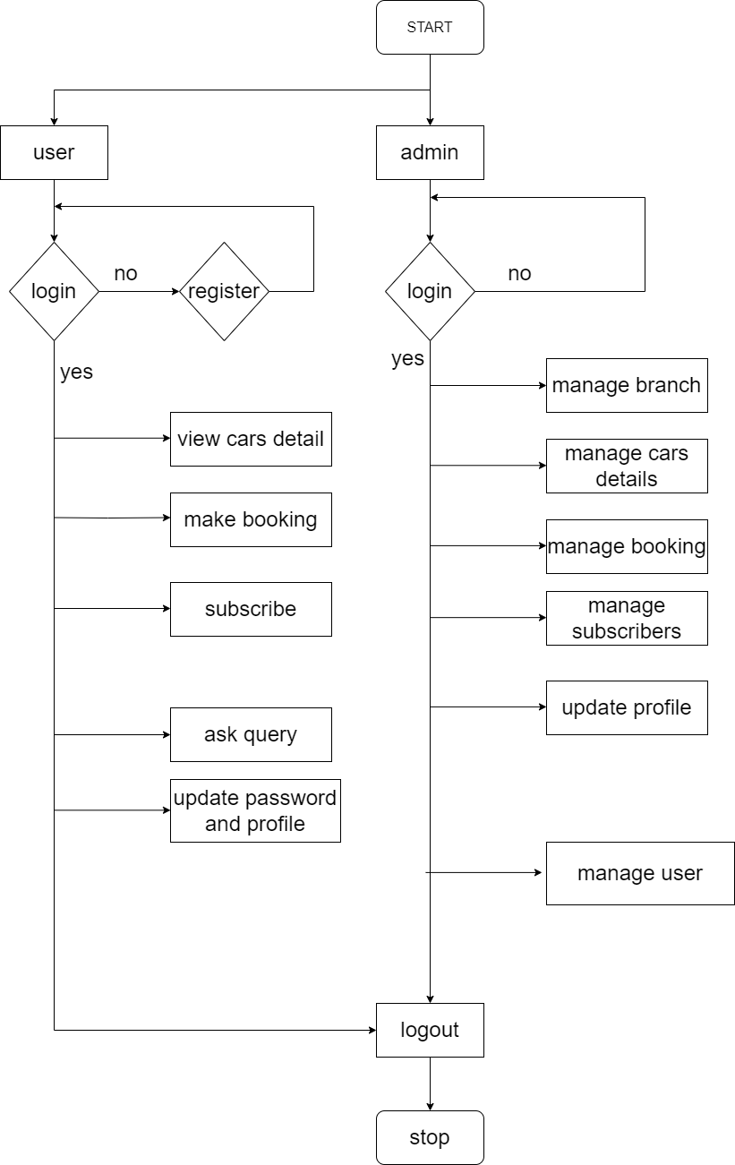

Figure 1. System Flow Diagram of <Car Rental System>

**Chapter 4**

**Data Flow Diagram (All Levels)**

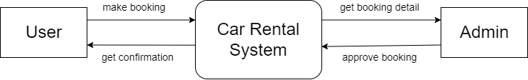

Figure 2. Data Flow Diagram of <Car Rental System>

**Chapter 4**

**Data Flow Diagram (All Levels)**

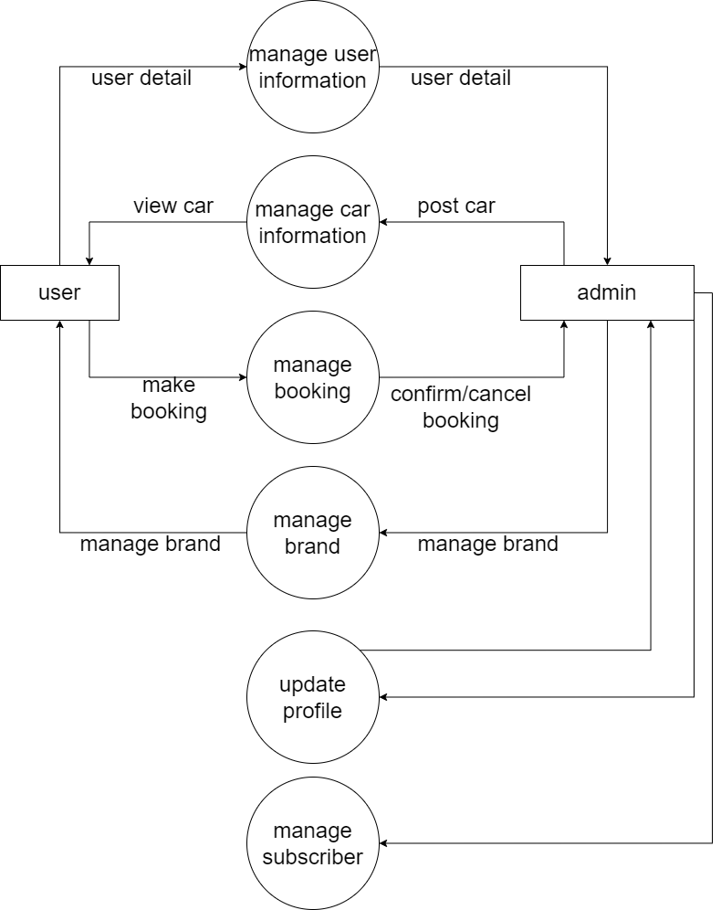

Figure 3. Data Flow Diagram of <Car Rental System>

**Chapter 4**

**Data Flow Diagram (All Levels)**

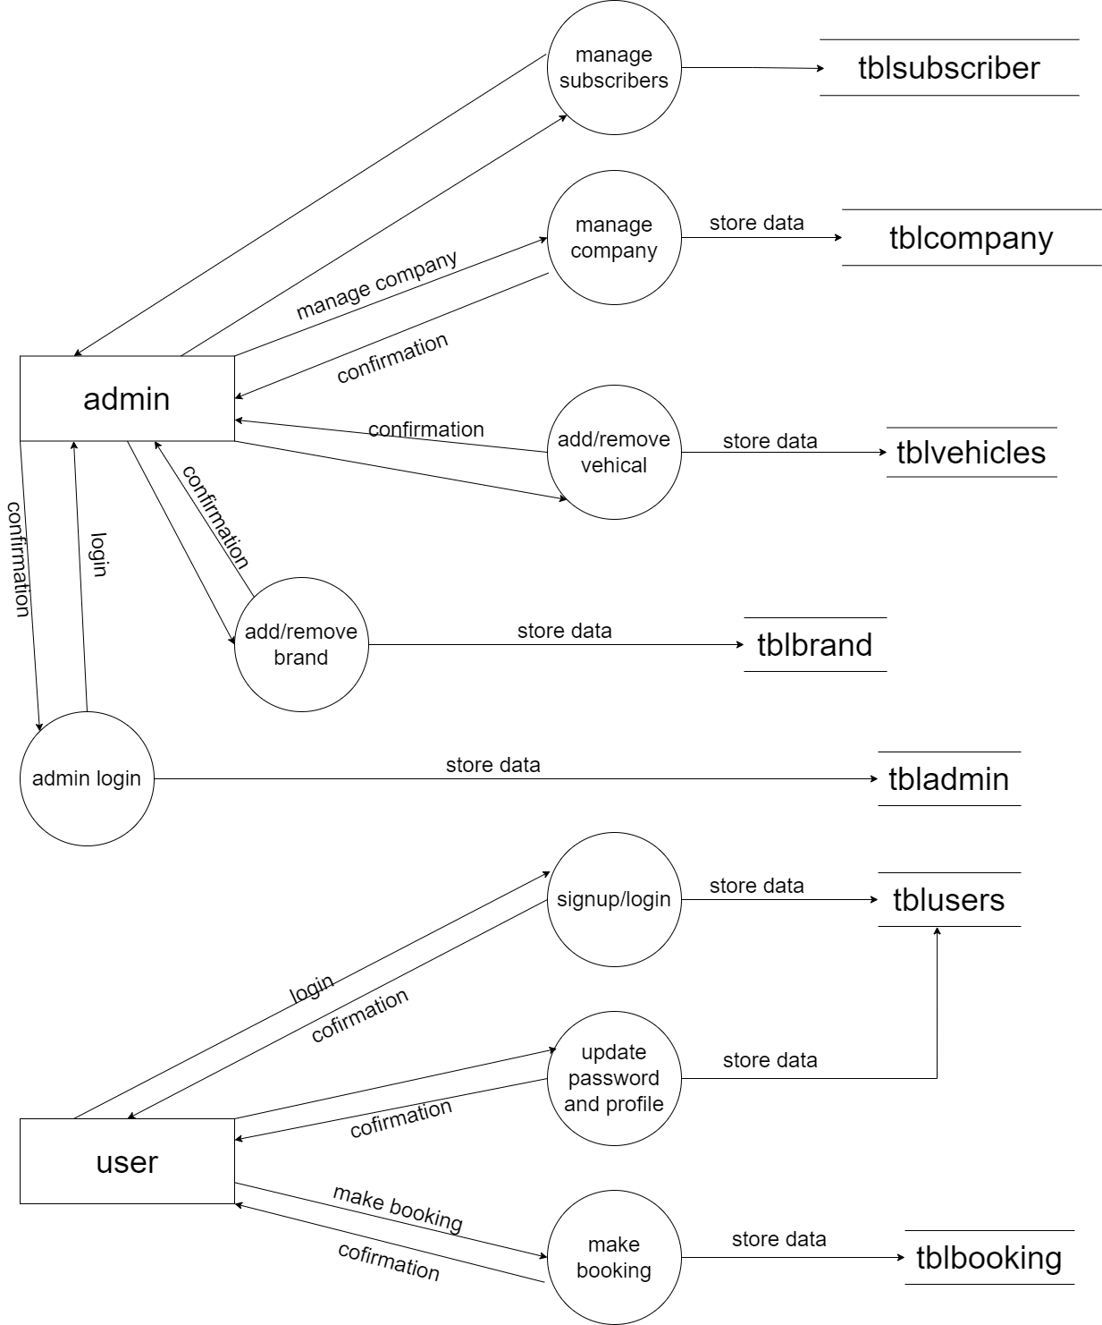

Figure 4. Data Flow Diagram of <Car Rental System>

**Chapter 5**

**Use Case Diagram**

**Use Case Diagram**

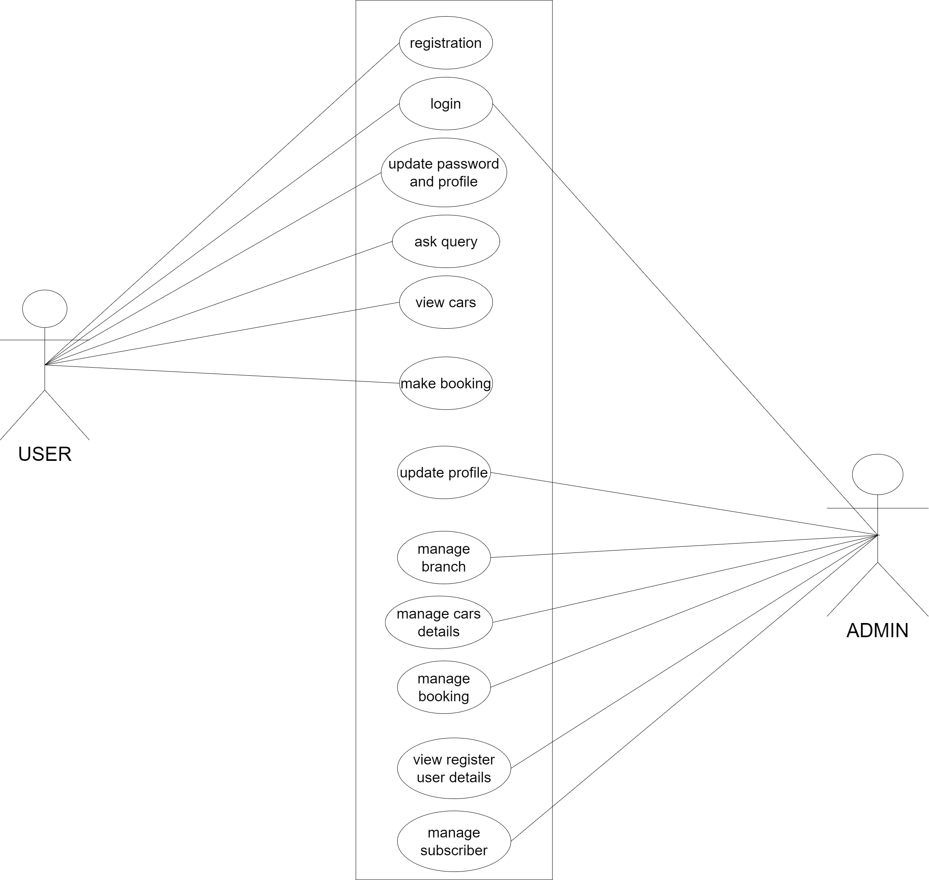

Figure 5. Use Case Diagram of <Car Rental System>

**Chapter 6**

**Data Dictionary**

**6.1 Admin** [Table Admin]

< Table Description>

|  |  |  |  |  |  |  |
| --- | --- | --- | --- | --- | --- | --- |
| **Sr. No.** | **Field Name** | **Data Type** | **Size** | **Constraint** | **Description** | **Example** |
| 1 | id | int | 11 | PRI |  |  |
| 2 | username | varchar | 100 |  |  |  |
| 3 | password | varchar | 100 |  |  |  |
| 4 | Update datetime | timestamp |  |  |  |  |

Table 1 Admin table

**6.2 Booking** [Table Booking]

< Table Description>

|  |  |  |  |  |  |  |
| --- | --- | --- | --- | --- | --- | --- |
| **Sr. No.** | **Field Name** | **Data Type** | **Size** | **Constraint** | **Description** | **Example** |
| 1 | Id | Int | 11 | PRI |  |  |
| 2 | bookingNumber | Bigint | 12 |  |  |  |
| 3 | userEmail | varchar | 100 |  |  |  |
| 4 | VehicleId | Int | 11 |  |  |  |
| 5 | FromDate | Varchar | 20 |  |  |  |
| 6 | ToDate | Varchar | 20 |  |  |  |
| 7 | message | Varchar | 255 |  |  |  |
| 8 | Ststus | Int | 11 |  |  |  |
| 9 | PostingDate | timestamp |  |  |  |  |
| 10 | LastUpdateDate | timestamp |  |  |  |  |

Table 2 Booking

**6.3 Brand** [Table Brand]

< Table Description>

|  |  |  |  |  |  |  |
| --- | --- | --- | --- | --- | --- | --- |
| **Sr. No.** | **Field Name** | **Data Type** | **Size** | **Constraint** | **Description** | **Example** |
| 1 | id | int | 11 | PRI |  |  |
| 2 | BrandName | varchar | 120 | NOT NULL |  |  |
| 3 | CreationDate | timestamp |  |  |  |  |
| 4 | UpdationDatetime | timestamp |  |  |  |  |

Table 3 Brand

**6.4 Users** [Table Users]

< Table Description>

|  |  |  |  |  |  |  |
| --- | --- | --- | --- | --- | --- | --- |
| **Sr. No.** | **Field Name** | **Data Type** | **Size** | **Constraint** | **Description** | **Example** |
| 1 | id | int | 11 | PRI |  |  |
| 2 | FullName | varchar | 120 |  |  |  |
| 3 | Emailid | varchar | 100 | MUL |  |  |
| 4 | Password | varchar | 100 |  |  |  |
| 5 | ContactNo | char | 11 |  |  |  |
| 6 | dob | varchar | 100 |  |  |  |
| 7 | Address | varchar | 255 |  |  |  |
| 8 | City | varchar | 100 |  |  |  |
| 9 | Country | varchar | 100 |  |  |  |
| 10 | RegDate | timestamp |  |  |  |  |
| 11 | UpdationDate | timestamp |  |  |  |  |

Table 4 User

**6.5 Vehicles** [Table Vehicles]

< Table Description>

|  |  |  |  |  |  |  |
| --- | --- | --- | --- | --- | --- | --- |
| **Sr. No.** | **Field Name** | **Data Type** | **Size** | **Constraint** | **Description** | **Example** |
| 1 | id | int | 11 | PRI |  |  |
| 2 | VehiclesTitle | varchar | 100 |  |  |  |
| 3 | VehiclesBrand | int | 100 |  |  |  |
| 4 | VehiclesOverview | longtext |  |  |  |  |
| 5 | PricePerDay | Int | 11 |  |  |  |
| 6 | FuelType | varchar | 100 |  |  |  |
| 7 | ModelYear | int | 6 |  |  |  |
| 8 | SeatingCapacity | Int | 11 |  |  |  |
| 9 | Vimage1 | varchar | 120 |  |  |  |
| 10 | Vimage2 | varchar | 120 |  |  |  |
| 11 | Vimage3 | varchar | 120 |  |  |  |
| 12 | Vimage4 | varchar | 120 |  |  |  |
| 13 | Vimage5 | varchar | 120 |  |  |  |
| 14 | AirConditioner | Int | 11 |  |  |  |
| 15 | PowerDoorLocks | Int | 11 |  |  |  |
| 16 | AntiLockBrakingSystem | Int | 11 |  |  |  |
| 17 | BrakeAssist | Int | 11 |  |  |  |
| 18 | PowerSteering | Int | 11 |  |  |  |
| 19 | DriverAirbag | Int | 11 |  |  |  |
| 20 | PassengerAirbag | Int | 11 |  |  |  |
| 21 | PowerWindows | Int | 11 |  |  |  |
| 22 | CDPlayer | int | 11 |  |  |  |
| 23 | CentralLocking | Int | 11 |  |  |  |
| 24 | CrashSensor | Int | 11 |  |  |  |
| 25 | LeatherSeats | Int | 11 |  |  |  |
| 26 | RegDate | timestamp |  | NOT NULL |  |  |
| 27 | UpdationDate | timestamp |  |  |  |  |

Table 5 Vehical

**6.1 Subscribers** [Table Subscribers]

< Table Description>

|  |  |  |  |  |  |  |
| --- | --- | --- | --- | --- | --- | --- |
| **Sr. No.** | **Field Name** | **Data Type** | **Size** | **Constraint** | **Description** | **Example** |
| 1 | id | Int | 11 | PRI |  |  |
| 2 | SubscriberEmail | varchar | 120 |  |  |  |
| 3 | Postingdate | timestamp |  |  |  |  |

<Table 1><Table Name>

**Chapter 7**

**Screenshot of Development Phase 1**

**7.1 <Form Name> Design**

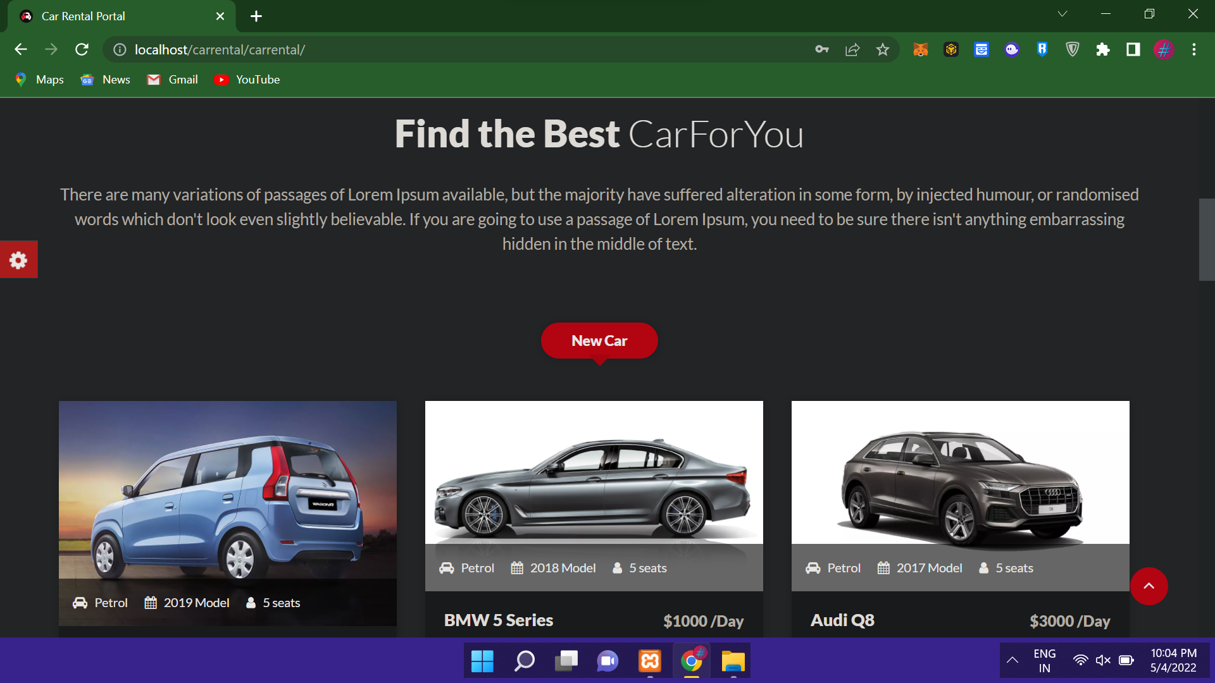

F

Figure 7.1 <Form Name>Design

**7.2Code of <Form Name>**

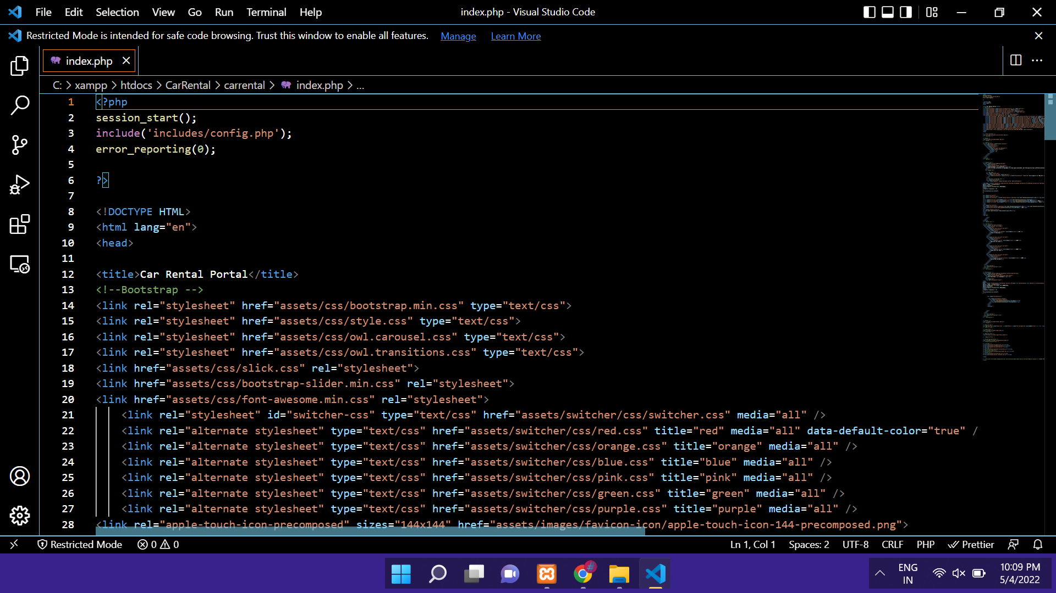

Figure 7.2 Code of <Form Name>

**Chapter 8**

**Screenshot of Development Phase 2**

**8.1 <Form Name> Design**

F

Figure 8.1 <Form Name>Design

**8.2Code of <Form Name>**

Figure 8.2 Code of <Form Name>

**Chapter 9**

**Screenshot of Development Phase 3**

**9.1 <Form Name> Design**

Figure 9.1 <Form Name>Design

**9.2Code of <Form Name>**

Figure 9.2 Code of <Form Name>

**Chapter 10**

**Conclusion**

**[It should be more than 10 lines]**

**Chapter 11**

**Future Enhancement**

**Chapter 12**

**References**

Website:

Book:

Other Resources: